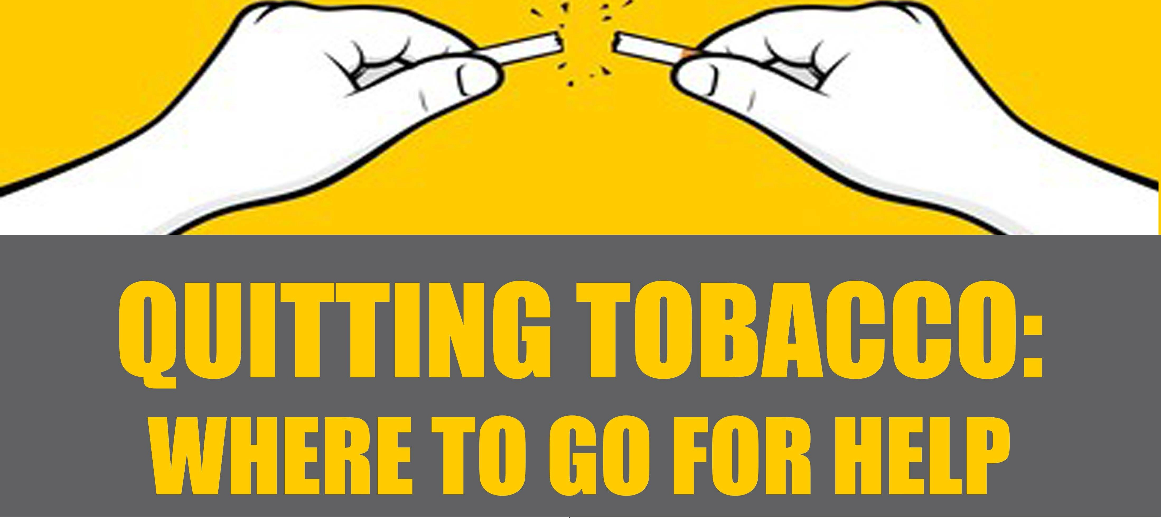

**Talk with** your medical provider at your MTF, ship or battalion aid station.

**Visit** your local health promotion office or wellness center for assistance.

Go to the DoD's YouCanQuit2 campaign for more information, chat support and resources on quitting tobacco: **YCQ2.org**.

**Call** 1-800-Quit Now to speak   
with your state quit coach.

Learn more from **Smokefree.gov**  
about ways to quit smoking and   
dipping or Text **QUIT**

to **47848** to get started.

Get support, tips and advice   
on quitting tobacco using free apps  
such as quitSTART and QuitGuide  
from **https://smokefree.gov/tools-tips/apps**.

Visit the Navy and Marine Corps Public Health Center’s Tobacco Free Living website for more resources: https://www.med.navy.mil/sites/nmcphc/health-promotion/tobacco-free-living/Pages/tobacco-free-living.aspx.

